ABSTRACT

Now days from health care industries large volume of data is generating. It is necessary to collect, store and process this data to discover knowledge from it and utilize it to take significant decisions. Diabetic is from the Non Communicable Diseases and lots of people are suffering from it. Now days, for developing countries such as India, Diabetics has become a big health issue. The Diabetics is one of the critical diseases which has long term complications associated with it and also follows with various health problems. With the help of technology, it is necessary to build a system that store and analyze the diabetic data and predict possible risks accordingly. Diabetes, when unnoticed may bring many serious diseases like heart attack, kidney disease Predictive analysis is a method that integrates various data mining techniques, machine learning algorithms and statistics that use current and past data sets to gain insight and predict future risks In this work, we proposed machine learning knowledge Decision Tree J48 calculation for diabetes forecast. Decision Tree is one of the powerful classification models. The dataset considered of 768 patients data with major 8 features and a target column with result “Positive” or “Negative”. Experiment is done with weka tool outcome of our demonstration shows that Decision Tree J48 calculation gives more efficiency with less processing time. The planned methodology that has been adopted for the classification and prediction, on the selected feature is J48 Decision Tree algorithm. Diabetes has affected over 246 million people worldwide with a majority of them being women. According to the WHO report, by 2025 this number is expected to rise to over 380 million. The disease has been named the fifth deadliest disease in the United States with no imminent cure in sight. With the rise of information technology and its continued advent into the medical and healthcare sector, the cases of diabetes as well as their symptoms are well documented. This paper aims at finding solutions to diagnose the disease by analyzing the patterns found in the data through classification analysis by employing Decision Tree . The research hopes to propose a quicker and more efficient technique of diagnosing the disease, leading to timely treatment of the patients.

CHAPTER -1
INTRODUCTION
Now days from health care industries large volume of data is generating. This data may be in the form of structured data or unstructured data. In the hospitals various records such as patients’ profile information, x-ray reports, various medical tests’ reports etc are preserved and this forms big data. Big data analytics is the process which examines such large data sets and uncovers hidden information, hidden patterns to discover knowledge from the data. Now days, in developing countries such as India, Diabetics has become a big health hazard. Big data analytics can be used to identify disease and its associated risk at early stages and can help to provide medical care accordingly. According to the current situations, in developing countries such as India, Diabetics has become a big health hazard. Diabetics is categorized as a Non Communicable Diseases and lots of people are suffering from it.
These days, diabetes is a typical disease influences the individual who has imbalance in blood glucose levels and furthermore pregnant women confronting diabetes issues. Diabetes is a general cause brought by high blood glucose level. Numerous investigations and research demonstrates that pregnant women with diabetes increasingly inclined to have a child with birth defects than ladies without diabetes. The child may influence by illness condition, for example, coronary illness and spina bifida. Diabetes mellitus mainly sorted as three types such as diabetes mellitus, insulin resistance and third one is gestational diabetes generally found in pregnant ladies.
Diabetes is a dangerous disease with the potential to cause a worldwide Health Care crisis. According to International Diabetes confederation 382 million people are living with diabetes world wide. By 2035, this will be doubled as 592 million. Early prediction of diabetes is quite challenging task for medical practitioners due to complex interdependence on various factors. Diabetes affects human organs such as kidney, eye, heart, nerves, foot etc. Data mining is a process to extract useful information from large database. It is a multidisciplinary field of computer science which involves computational process, machine learning, statistical techniques, classification, for all.

1.2 OBJECTIVE
The main objective of this project is to develop a prototype Intelligent Diabetics Disease Prediction System using data mining modeling technique Decision Tree j48. It can discover and extract hidden knowledge (patterns and relationships) associated with Diabetics disease from a historical diabetics disease database. It can answer complex queries for diagnosing Diabetics disease and thus assist healthcare practitioners to make intelligent clinical decisions which traditional decision support systems cannot. By providing effective treatments, it also helps to reduce treatment costs. To enhance visualization and ease of interpretation, it displays the results both in tabular and graphical forms.

1.3 OVERVIEW OF DIABETES
Diabetes is a disease that occurs when the insulin production in the body is inadequate or the body is unable to use the produced insulin in a proper manner, as a result, this leads to high blood glucose. The body cells break down the food into glucose and this glucose needs to be transported to all the cells of the body. The insulin is the hormone that directs the glucose that is produced by breaking down the food into the body cells. Any change in the production of insulin leads to an increase in the blood sugar levels and this can lead to damage to the tissues and failure of the organs. Generally, a person is considered to be suffering from diabetes, when blood sugar levels are above normal (4.4 to 6.1 mmol/L).

There are certain things that everyone who has diabetes, whether type 1 or type 2, needs to do to be healthy. They need to have a meal (eating) plan. They need to pay attention to how much physical activity they engage in, because physical activity can help the body use insulin better so it can convert glucose into energy for cells. Everyone with type 1 diabetes, and some people with type 2 diabetes, also need to take insulin injections. Some people with type 2 diabetes take pills called "oral agents" which help their bodies produce more insulin and/or use the insulin it is producing better output .

1.4 Types of Diabetes
The three main types of diabetes are described below:
Type 1:
Though there are only about 10% of diabetes patients have this form of diabetes, recently, there has been a rise in the number of cases of this type in the United States. The disease manifest as an autoimmune disease occurring at a very young age of below 20 years hence also called juvenile-onset diabetes. In this type of diabetes, the pancreatic cells that produce insulin have been destroyed by the defense system of the body. Injections of insulin along with frequent blood tests and dietary restrictions have to be followed by patients suffering from Type 1 diabetes.
Type 2:
This type accounts for almost 90% of the diabetes cases and commonly called the adult-onset diabetes or the non-insulin dependent diabetes. In this case the various organs of the body become insulin resistant, and this increases the demand for insulin. At this point, pancreas doesn’t make the required amount of insulin. To keep this type of diabetes at bay, the patients have to follow a strict diet, exercise routine and keep track of the blood glucose. Obesity, being overweight, being physically inactive can lead to type 2 diabetes. Also with ageing, the risk of developing diabetes is considered to be more. Majority of the Type 2 diabetes patients have border line diabetes or the Pre-Diabetes, a condition where the blood glucose levels are higher than normal but not as high as a diabetic patient.

Type 3:
Gestational diabetes is a condition in which a woman without diabetes develops high blood sugar levels during pregnancy. Gestational diabetes generally results in few symptoms; however, it does increase the risk of pre-eclampsia, depression, and requiring a Caesarean section. Babies born to mothers with poorly treated gestational diabetes are at increased risk of being too large, having low blood sugar after birth, and jaundice. If untreated, it can also result in a stillbirth. Long term, children are at higher risk of being overweight and developing type 2 diabetes.

CHAPTER-2
Literature Survey
Survey 1:
Gopalakrishna Palam, "The Practice of predictive analytics in healthcare", September 2015.

In these days, chronic diseases are the imperative reason for death in the world. Therefore, there is a noteworthy increment in consideration being paid to individual wellness as a preventative methodology in healthcare. However, creating and building a prediction model for chronic diseases is an extraordinary change to healthcare technology on the premise of data-analysis and decision-making level. In this paper, effective mechanisms have been used for chronic disease prediction by mining the data containing historical health records. Here, we used Naïve Bayes, Decision tree, Support Vector Machine (SVM) and Artificial Neural Networks (ANN) classifiers for the diagnosis of diabetes and heart disease. In this study, we also present comparative study of different classifiers to measure the performance based on accuracy rate.

Survey 2:
C. Cortes, V. Vapnik, "Support-vector networks", Machine Learning, vol. 20, no. 2, pp. 273-297, 1995.
The support-vector network is a new learning machine for two-group classification problems. The machine conceptually implements the following idea: input vectors are non-linearly mapped to a very high-dimension feature space. In this feature space a linear decision surface is constructed. Special properties of the decision surface ensure high generalization ability of the learning machine. The idea behind the support-vector network was previously implemented for the restricted case where the training data can be separated without errors. We here extend this result to non-separable training data.
High generalization ability of support-vector networks utilizing polynomial input transformations is demonstrated. We also compare the performance of the support-vector network to various classical learning algorithms that all took part in a benchmark study of Optical Character Recognition.
Survey 3:
Christopher J.C. Burges, "A Tutorial on Support Vector Machines for Pattern Recognition" in Data Mining and Knowledge Discovery, Springer, vol. 2, no. 2, pp. 121-167, 1998.

The tutorial starts with an overview of the concepts of VC dimension and structural risk minimization. We then describe linear Support Vector Machines (SVMs) for separable and non-separable data, working through a non-trivial example in detail. We describe a mechanical analogy, and discuss when SVM solutions are unique and when they are global. We describe how support vector training can be practically implemented, and discuss in detail the kernel mapping technique which is used to construct SVM solutions which are nonlinear in the data. We show how Support Vector machines can have very large (even infinite) VC dimension by computing the VC dimension for homogeneous polynomial and Gaussian radial basis function kernels. While very high VC dimension would normally bode ill for generalization performance, and while at present there exists no theory which shows that good generalization performance is guaranteed for SVMs, there are several arguments which support the observed high accuracy of SVMs, which we review. Results of some experiments which were inspired by these arguments are also presented. We give numerous examples and proofs of most of the key theorems. There is new material, and I hope that the reader will find that even old material is cast in a fresh light.
Survey 4:
Ravi S. Behra, Pranitha Pulumati, Ankur Agarwal, Ritesh Jain, M.D Vinaya Rao, "Predictive Modeling for Wellness and Chronic Conditions", 2014 IEEE 14th International Conference on Bioinformatics and Bioengineering.

There is a significant increase in attention being paid to personal wellness as a preventative strategy in healthcare. At the same time, chronic diseases are the major cause of mortality, accounting for 7 out of 10 deaths in the United States. Healthcare costs involved in managing chronic diseases are also very high. So there is a need to help better maintain individual wellness, as well as better manage chronic conditions. Predictive analytics based clinical decision support systems need to be developed to help individuals and healthcare providers to better manage wellness or chronic conditions. In this paper, we investigate two different classifiers to predict the wellness outcome and the occurrence of a chronic condition (diabetes). The models were evaluated on the basis of overall accuracy, root mean squared error and Area under ROC. National CDC-NHANES data that is based on the health and nutritional status of individuals in the United States is used to develop the models.

Survey 5:
A. A. Bakar, Z. Kefli et al., "Predictive Models For Dengue Outbreak Using Multiple Rulebase Classifiers", Electrical Engineering and Informatics (ICEEI) International Conference on, pp. 1-6, 17–19 July 2011.
The paper aims to develop the predictive models for dengue outbreak detection using Multiple Rule Based Classifiers. The rule based classifiers used are the Decision Tree, Rough Set Classifier, Naive Bayes, and Associative Classifier. Dengue fever (DF) and dengue hemorrhagic fever (DHF) have been continuously becoming a public health related issues in Malaysia and growing pandemic as reported by World Health Organization (WHO). It is important for the government to able to make early detection for dengue outbreak. Thus, to improve early detection of the dengue outbreak and making such strategic planning and decision, being able to predict or forecast the possible dengue outbreak in an area is critically important. The purpose of the classification modelling is to build a predictive model for predicting the dengue outbreak. Since to date there is no research uses this data for predictive modelling, several classifiers are investigated to study the performance of various rule based classifiers individually and the combination of the classifiers. The experimental results show that the multiple classifiers are able produce better accuracy (up to 70%) with more quality rules compared to the single classifier.
Survey 6:
J. R. Quinlan, "Introduction Of Decision Tree", Machine Learning Journal, vol. 1, pp. 81-106, 1986.

The technology for building knowledge-based systems by inductive inference from examples has been demonstrated successfully in several practical applications. This paper summarizes an approach to synthesizing decision trees that has been used in a variety of systems, and it describes one such system, ID3, in detail. Results from recent studies show ways in which the methodology can be modified to deal with information that is noisy and/or incomplete. A reported shortcoming of the basic algorithm is discussed and two means of overcoming it are compared. The paper concludes with illustrations of current research directions.

CHAPTER-3
AIM AND SCOPE OF THE PRESENT INVESTIGATION

AIM :
The primary aim of our work is to classify gestational diabetic or non gestational diabetic. Proposed work is based on decision tree j48. Major study of classification systems give high accuracy with high handling time, though a few strategies give low precision even with enormous dataset. Along these lines, our work goes for high accuracy with immense dataset and less process time invited articles in the journals.
Existing Methods:
Numerous works has been proposed on diabetes discovery systems exploiting machine learning clustering, classification, information mining and learning. In this study, few of them is discussed with their concise proposition. One of the works done in machine learning utilizing Decision tree J48 for Diabetes Mellitus dependent on risk factors. In their system they demonstrated that Adaboost outperforms as far as efficiency is concerned than bagging and Decision tree J48.

Deepti et.al. in [2] examined execution performance of classification algorithms specifically Decision Tree, SVM and Naive Bayes. In their work they considered Pima Diabetes Database (PIDD), though the highest accuracy accomplished by their work is around 76.3%. In our proposed work, we attempted to accomplish over 80% by considering the equivalent dataset.

The classification technique on machine learning namely SVM for diabetes detection is exploited by Santi Waulan [3], they proposed improved version of SVM namely Smooth SVM (SSVM) and MKS-SSVM. They demonstrated over Pima dataset. In their results, they achieved about high accuracy for MKS-SSVM for it .

Faezeh et al [4] considered Fuzzy Clustering method (FACT), which decides the quantity of fitting clusters dependent on density. The proposed algorithm is insensitive to initial number of clusters, while initial cluster numbers are less than threshold number of clusters. Their strategy discovered number of cluster by making new cluster focuses through outlier detection. In their work, they demonstrated experimentally that proposed heuristic algorithm exhibit a superior performance .
PROPOSED SYSTEM
In our proposed work, we considered classification algorithm, Decision Tree J48 and applied over Pima Indians Diabetes Database. This dataset is analyzed using weka tool. Many data mining tools were available, whereas weka is found to be efficient and easy to use for research and analysis purpose. Out of many available classification algorithms, Decision Tree J48 is preferred for its better accuracy on prediction part.
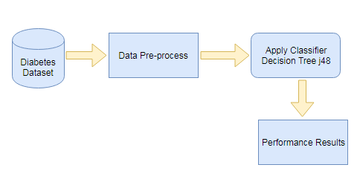

SOFTWARE DESCRIPTION
3.2.1 JAVA
Implementation is the stage of the project when the theoretical design is turned into a working system. Thus it can be considered to be the most critical stage in achieving a successful new system and in giving the user confidence that the new system will work and be effective. The implementation stage involves careful planning, investigation of the existing system and its constraints on implementation, designing of methods to achieve changeover and evaluation of changeover methods Java is a programming language and computing platform first released by Sun Microsystems in 1995. There are lots of applications and websites that will not work unless you have Java installed, and more are created every day. Java is fast, secure, and reliable. From laptops to datacenters, game consoles to scientific supercomputers, cell phones to the Internet, Java is everywhere! The Java Virtual Machine is only one aspect of Java software that is involved in web interaction. The Java Virtual Machine is built right into your Java software download, and helps run Java applications.

3.2.2 FEARURES AND BENEFITS
There are various Features and Benefits in implementing the java language in the project.
Platform Independent
The concept of Write-once-run-anywhere (known as the Platform independent) is one of the important key feature of java language that makes java as the most powerful language. Not even a single language is idle to this feature but java is closer to this feature. The programs written on one platform can run on any platform provided the platform must have the JVM.
Simple
There are various features that makes the java as a simple language. Programs are easy to write and debug because java does not use the pointers explicitly. It is much harder to write the java programs that can crash the system but we cannot say about the other programming languages. Java provides the bug free system due to the strong memory management. It also has the automatic memory allocation and Reallocation system.
Robust
Java has the strong memory allocation and automatic garbage collection mechanism. It provides the powerful exception handling and type checking mechanism as compare to other programming languages .Compiler checks the program whether there any error and interpreter checks any run time error and makes the system secure from crash. All of the above features makes the java language robust.
Portable
The feature Write-once-run-anywhere makes the java language portable provided that the system must have interpreter for the JVM. Java also have the standard data size irrespective of operating system or the processor. These features makes the java as a portable language. A portable computer was a computer designed to be easily moved from one place to another and included a display and keyboard. Portable computers, by their nature, were generally microcomputers.

Dynamic
While executing the java program the user can get the required files dynamically from a local drive or from a computer thousands of miles away from the user just by connecting with the Internet.
Secure
Java does not use memory pointers explicitly. All the programs in java are run under an area known as the sand box. Security manager determines the accessibility options of a class like reading and writing a file to the local disk. Java uses the public key encryption system to allow the java applications to transmit over the internet in the secure encrypted form. The byte code Verifier checks the classes after loading.
Performance
Java uses native code usage, and lightweight process called threads. In the beginning interpretation of byte code resulted the performance slow but the advance version of JVM uses the adaptive and just in time compilation technique that improves the performance.
3.2.3 BENEFITS OF JAVA
The computer world currently has many platforms. This has its pros and cons. On the one hand it gives more choices to people; on the other hand it becomes more and more difficult to produce software that runs on all platforms. With its Java Virtual Machine and API, the Java Platform provides an ideal solution to this. The Java Platform is designed for running highly interactive, dynamic, and secure applets and applications on networked computer systems. Being interactive, dynamic and architecture-neutral, the Java Platform has benefits not only for the developer and support personnel, but also for the end user.
For the end users, the platform provides live, interactive content on the World Wide Web, with just-in-time software access. Applications are readily available on all operating systems at once. Users do not have to choose operating systems based on the applications, they can run the applications on their favourite machines.
Developers can develop applications on one platform to deliver to that same platform -- the Java Platform, which is available on a wide variety of OS and hardware platforms. This much reduces the developing cost.
For support personnel, version control and upgrades are much simplified because Java-enabled application can be kept in a central repository and served from there for each individual use.
Goals of Java:
- Provide an easy to use.

- Being object oriented.

- JVM (java virtual machine).

- Garbage Collection.

- The java virtual machine (JVM) provide the hardware platform specification to which you compile all java technology code

- Garbage Collection is a allocated memory that is no longer needed should be reallocated.

- It checks for frees memory no longer needed.

HTML:
HTML is a markup language that are used to create electronic documents, especially
pages on the World Wide Web that contain connections called hyperlinks to otherpages. Every web page you see on the Internet, including this one contains HTML code that helps format and show text and images in an easy to read format. Without HTML a browser would not know how to format a page and would only display the early days of the world wide web, marking up text-based documents using HTML syntax was more than sufficient to facilitate the sharing of academic documents and technical memos. However, as the internet expanded beyond the walls of academia and into the homes of the general population, greater demand was placed on webpages in terms of formatting and interactivity. The idea of using text to describe how text should be displayed might sound somewhat paradoxical, but it is not. This is the whole reason why HTML is known as a markup language.

CSS:

CSS is a style sheet language used for describing the presentation of a document for
written in a markup language. Although most often used to set the visual style of web
pages and user interfaces written in HTML and XHTML, the language can be applied to any XML document, including plain XML, SVG and XUL, and is applicable to rendering in speech, or on other media. Along with HTML and JavaScript, CSS is a cornerstone technology used by most websites to create visually engaging for the in an
webpages, user interfaces for web applications, and user interfaces for many mobile applications.

JavaScript :
JavaScript HTML and CSS, JavaScript is one of three core technologies of World Now
JavaScript is a dynamic computer programming language. It is lightweight and most commonly used as a part of web pages, whose implementations allow client-side script to interact with the user and make dynamic pages. It is an interpreted programming language with object-oriented capabilities.JavaScript was first known as LiveScript, but Netscape changed its name to JavaScript, possibly because of the excitement being generated by Java. JavaScript made its first appearance in Netscape 2.0 in 1995 with the name LiveScript. The general-purpose core of the language has been embedded in Netscape, Internet Explorer, and other web browsers.The ECMA-262 Specification defined a standard version of the core JavaScript language. Client-side JavaScript is the most common form of the language. The script should be included in or referenced by an HTML document for the code to be interpreted by the browser.It means that a web page need not be a static HTML, but can include programs that interact with the user, control the browser, and dynamically create HTML content.

JAVA SERVLETS :
Java Server Page (JSP) is a server-side technology, Java Server Pages are an extension to the Java servlet technology that was developed by sun. The overview of
JSPs have dynamic scripting capability that works in tandem with HTML code, separating the page logic from the static elements -- the actual design and display of the page -- to help make the HTML more functional(i.e. dynamic database queries).for
A JSP is translated into Java servlet before being run, and it processes HTTP requests and generates responses like any servlet. However, JSP technology provides a more convenient way to code a servlet. Translation occurs the first time the application is run. A JSP translator is triggered by the .jsp file name extension in a URL. JSPs are fully interoperable with servlets. You can include output from a servlet or forward the output to a servlet, and a servlet can include output from a JSP or forward output to a JSP.

Apache Server (XAMPP):

The Apache HTTP Server [9], commonly referred to as Apache is a web server and in
application notable for playing a key role in the initial growth of the World Wide Web and creates a localhost server. Apache is developed and maintained by an open community of developers under the auspices of the Apache Software Foundation. Most commonly used on a Unix like system, Microsoft Windows, OS/2, TPF, OpenVMS and
eComStation. Released under the Apache License, Apache is open-source software.

Data Flow Diagram :

LEVEL-0 :

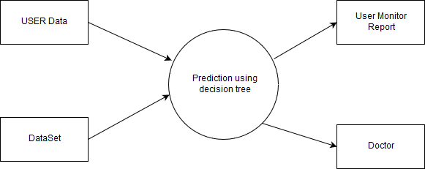

LEVEL-2 :

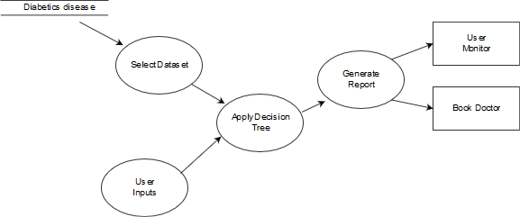

UML diagrams

UML is an acronym that stands for Unified Modelling Language. Simply put, UML is a modern approach to modeling and documenting software. In fact, it’s one of the most popular business process modeling technique

It is based of software components. As the old proverb says: “a picture is worth a thousand words”. By using visual representations, we are able to better understand possible flaws or errors in software or business processes.

UML was created as a result of the chaos revolving around software development and documentation. In the 1990s, there were several different ways to represent and document software systems. The need arose for a more unified way to visually represent those systems and as a result, in 1994-1996, the UML was developed by three software at Rational Software. It was later adopted the standard in 1997 and has remained the standard ever since, receiving only a few updates.

Types of UML Diagrams:

Activity diagram
Sequence diagram
Collaboration diagram
Component diagram and Deployment diagram
Use case diagram

Activity diagram :

Activity diagrams are probably the most important UML diagrams for doing business

Generating Questions

Diabetics

Find doctor details and medication information

Generating questionnaire

Getting Input

Find location

Apply decision tree classifier to diabetics disease database

Find chance of occurrence of heart disease

Generate result
Sequence diagram:

Sequence diagrams are probably the most important UML diagrams among not only the computer science community but also as design-level models for business application development. Lately, they have become popular in depicting business processes, because of their visually self-explanatory nature.

As the name suggests, sequence diagrams describe the sequence of messages and interactions that happen between actors and objects. Actors or objects can be active only when needed or when another object wants to communicate with them. All communication is represented in a chronological manner. To get a better idea, check the example of a UML sequence diagram.

As the name suggests, structural diagrams are used to depict the structure of a system. More specifically, it is used in software development to represent the architecture of the system and how the different components are interconnected (not how they behave or communicate, simply at end.

Collaboration diagram :

A collaboration diagram, also called a communication diagram or interaction diagram, is an illustration of the relationships and interactions among software objects in the Unified Modeling Language (UML). The concept is more than a decade old although it has been refined as modeling paradigms have evolved.

Collaboration diagrams are best suited to the portrayal of simple interactions among relatively small numbers of objects. As the number of objects and messages grows, a collaboration diagram can become difficult to read. Several vendors offer software for creating and editing collaboration diagrams.

Component and Deployment diagram

The component diagram shows how the physical components or packages interact with one another. The above diagram shows that the client and the server are related to one another, using the input given by the user and the output generated. Deployment diagram shows the configuration of runtime processing elements and software components, processes and objects that live in them.

For example, Lambda architecture is the typical example of a complex architecture that can be represented using a component UML diagram. Lambda architecture is a data-processing architecture employed by several companies for storing and processing data in a distributed system. It is made up of three different layers: the speed layer, the batch layer and the serving layer.

Use case diagram :
The database is available on the server side. The corresponding questionnaire is sent to the client system. The input got from the client and the datasets will be used by the system which uses decision tree classifier to generate the chance of occurrence of the disease. The generated result will be sent to the client system. If necessary it will be sent to the doctor’s mail address. This data can also be used to store in the database for future reference by the doctor

Generate PDF file
Generate chance of occurrence of disease
Implementing decision tree
Test data
Select database
Choice of disease

CHAPTER-4
EXPERIMENTAL OR MATERIAL AND METHODS

Modules :
- Analyzing the Data set
- Decision tree J48 Implementation.
- Dataset Used.
- Get Input from User’s
- Diagnosis in WEB system

Modules Description :

- Analyzing the Data set
A data set is a collection of data, usually presented in tabular form. Each column represents a particular variable. Each row corresponds to a given member of the data set in question. It lists values for each of the variables, such as height and weight of an object or values of random numbers. Each value is known as a datum. The data set may comprise data for one or more members, corresponding to the number of rows.
The values may be numbers, such as real numbers or integers, for example representing a person's height in centimeters, but may also be nominal data (i.e., not consisting of numerical values), for example representing a person's ethnicity. More generally, values may be of any of the kinds described as a level of measurement. For each variable, the values will normally all be of the same kind. However, there may also be "missing values", which need to be indicated in some way.

The attribute “Diagnosis” was identified as the predictable attribute with value “1” for patients with diabetics disease and value “0” for patients with no diabetics disease. The attribute “Patient id” was used as the key; the rest are input attributes. It is assumed that problems such as missing data, inconsistent data, and duplicate data have resolve.
Here in our project we get a data set from .arf file as our file reader program will get the data from them for the input of Decision tree j48 based mining process.

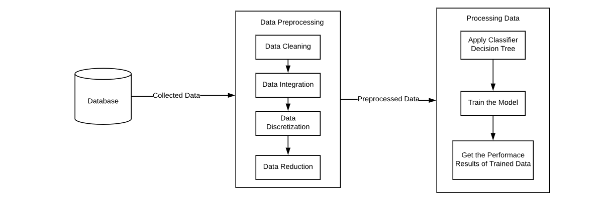

- Decision tree j48 Implementation in Mining :

Decision Tree is a supervised machine learning algorithm used to solve classification problems. The main objective of using Decision Tree in this research work is the prediction of target class using decision rule taken from prior data. It uses nodes and internodes for the prediction and classification. Root nodes classify the instances with different features. Root nodes can have two or more branches while the leaf nodes represent classification. In every stage, Decision tree chooses each node by evaluating the highest information gain among all the attributes.
Classification is the process of building a model of classes from a set of records that contain class labels. Decision Tree Algorithm is to find out the way the attributes-vector behaves for a number of instances. Also on the bases of the training instances the classes for the newly generated instances are being found. This algorithm generates the rules for the prediction of the target variable. With the help of tree classification algorithm the critical distribution of the data is easily understandable. J48 is an extension of ID3. The additional features of J48 are accounting for missing values, decision trees pruning, continuous attribute value ranges, derivation of rules, etc. In the WEKA data mining tool, J48 is an open source Java implementation of the C4.5 algorithm. The WEKA tool provides a number of options associated with tree pruning. In case of potential over fitting pruning can be used as a tool for précising. In other algorithms the classification is performed recursively till every single leaf is pure, that is the classification of the data should be as perfect as possible. This algorithm it generates the rules from which particular identity of that data is generated. The objective is progressively generalization of a decision tree until it gains equilibrium of flexibility and accuracy

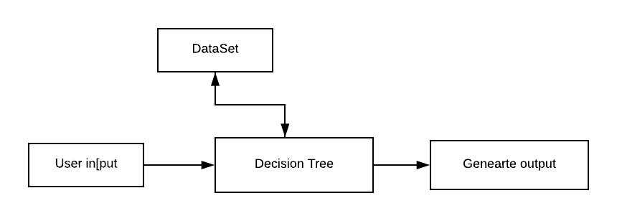

- Dataset Used :

In this work WEKA tool is used for performing the experiment. WEKA is a software which is designed in the country New Zealand by University of Waikato, which includes a collection of various machine learning methods for data classification, clustering, regression, visualization etc. One of the biggest advantages of using WEKA is that it can be personalized according to the requirements. The main aim of this study is the prediction of the patient affected by diabetes using the WEKA tool by using the medical database PIDD. Table-4 shows a brief description of the dataset.

Table 4. Dataset Description
Database | No. of Attributes | No. of Instances
PIDD | 8 | 768

PIDD-Pima Indians Diabetes Dataset:

The proposed methodology is evaluated on Diabetes Dataset namely (PIDD), which is taken from UCI Repository. This dataset comprises of medical detail of 768 instances which are female patients. The dataset also comprises numeric-valued 8 attributes where value of one class ’0’ treated as tested negative for diabetes and value of another class ’1’ is treated as tested positive for diabetes.
Attribute | Abbreviation of Attributes
1. Number of times pregnant | Pr
2. Plasma glucose concentration | Pl
3. Diastolic blood pressure (mm Hg) | Pr
4. Skin fold thickness (mm) | Sk
5. 2-Hour serum insulin (mu U/ml) | In
6. BMI (weightinkg/(heightinm)2) | Ma
7. Diabetes pedigree function | Pe
8. Age in years | Ag
9. Class ’0’ or ’1’ | Cl

Accuracy (A):
Accuracy determines the accuracy of the algorithm in predicting instances
A = (TP+TN) / (Total no of samples)
Precision (P):
Classifiers correctness/accuracy is measured by Precision.
P = TP / (TP+ FP)
Recall (R):
To measure the classifiers completeness or sensitivity, Recall is used.
R=TP/ (TP+FN)
F-Measure (F):
F-Measure is the weighted average of precision and recall.
F=2*(P*R) / (P+R)
Corresponding classifiers performance over Accuracy, Precision, F-measure, Recall and ROC values are listed in Table-7

Classification Algorithms | Precision | Recall | F-Measure | Accuracy %
Decision Tree J48 | 0.735 | 0.733 | 0.735 | 73.30

Where, TP defines True Positive,
TN defines True Negative,
FP defines False positive,
FN defines False Negative.

4 . Getting input from user’s

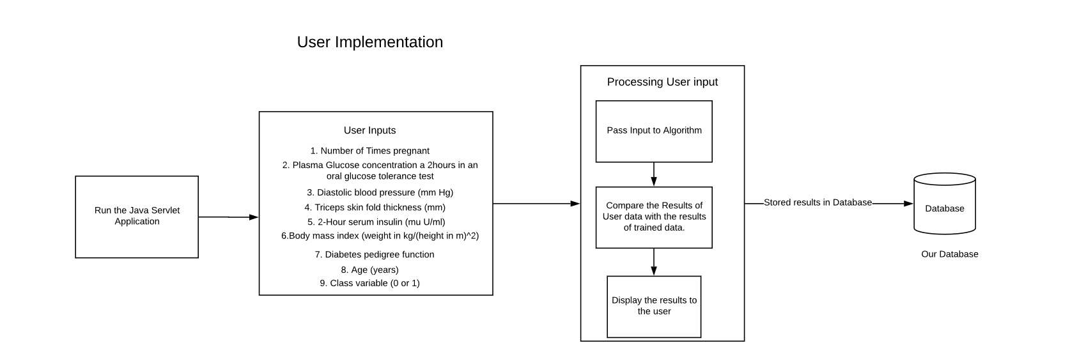

CHAPTER-5

5.1 Results and Diucssuion:

Precision | 0.804
Recall | 0.780
F-Measure | 0.792
Mean absolute error | 0.312
Root Mean square error | 0.4528

Tested _negative | 390 | 110
Tested _positive | 95 | 173

Total no of instances | Classification Algorithms | Correctly Classified Instances | Incorrectly Classified Instances
768 | Decision Tree | 563 | 205

=== Classifier model (full training set) ===

J48 pruned tree
------------------

plas <= 127
| mass <= 26.4: tested_negative (132.0/3.0)
| mass > 26.4
| | age <= 28: tested_negative (180.0/22.0)
| | age > 28
| | | plas <= 99: tested_negative (55.0/10.0)
| | | plas > 99
| | | | pedi <= 0.561: tested_negative (84.0/34.0)
| | | | pedi > 0.561
| | | | | preg <= 6
| | | | | | age <= 30: tested_positive (4.0)
| | | | | | age > 30
| | | | | | | age <= 34: tested_negative (7.0/1.0)
| | | | | | | age > 34
| | | | | | | | mass <= 33.1: tested_positive (6.0)
| | | | | | | | mass > 33.1: tested_negative (4.0/1.0)
| | | | | preg > 6: tested_positive (13.0)
plas > 127
| mass <= 29.9
| | plas <= 145: tested_negative (41.0/6.0)
| | plas > 145
| | | age <= 25: tested_negative (4.0)
| | | age > 25
| | | | age <= 61
| | | | | mass <= 27.1: tested_positive (12.0/1.0)
| | | | | mass > 27.1
| | | | | | pres <= 82
| | | | | | | pedi <= 0.396: tested_positive (8.0/1.0)
| | | | | | | pedi > 0.396: tested_negative (3.0)
| | | | | | pres > 82: tested_negative (4.0)
| | | | age > 61: tested_negative (4.0)
| mass > 29.9
| | plas <= 157
| | | pres <= 61: tested_positive (15.0/1.0)
| | | pres > 61
| | | | age <= 30: tested_negative (40.0/13.0)
| | | | age > 30: tested_positive (60.0/17.0)
| | plas > 157: tested_positive (92.0/12.0)

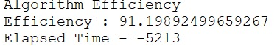

LOGIN PAGE

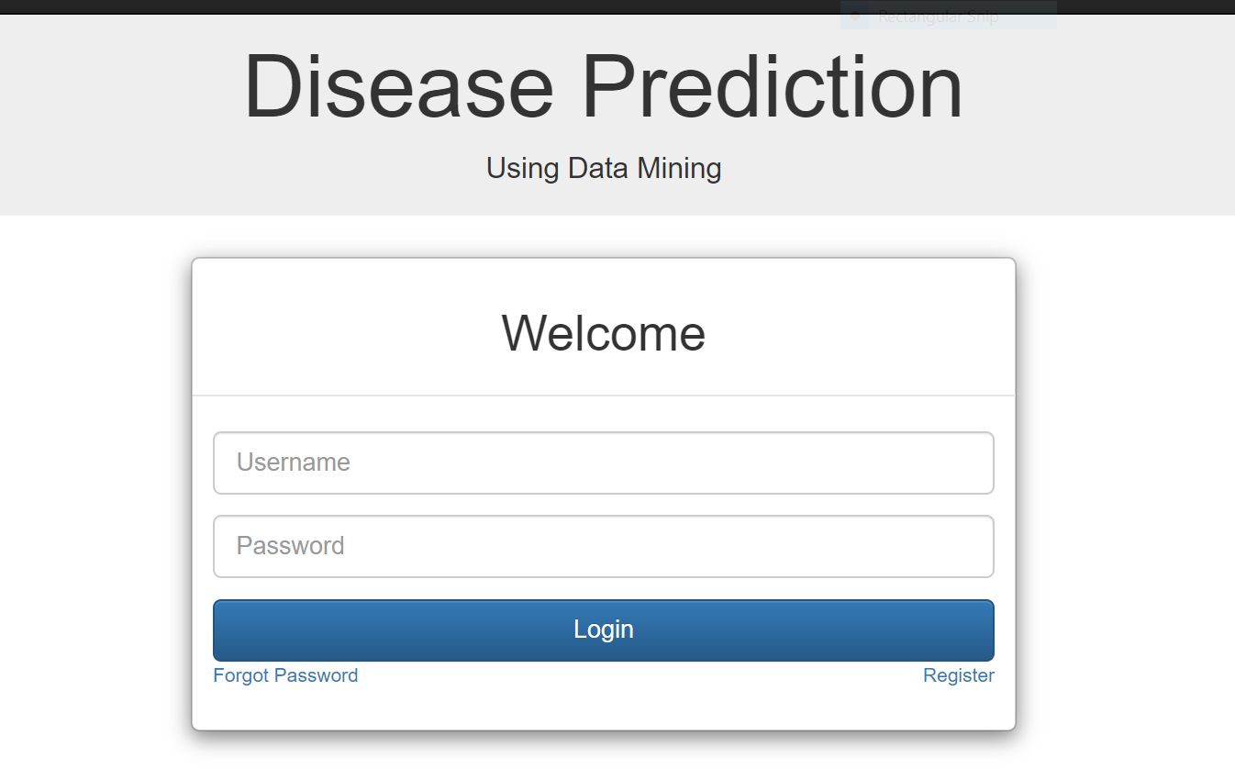

TYPE OF ACCOUT:

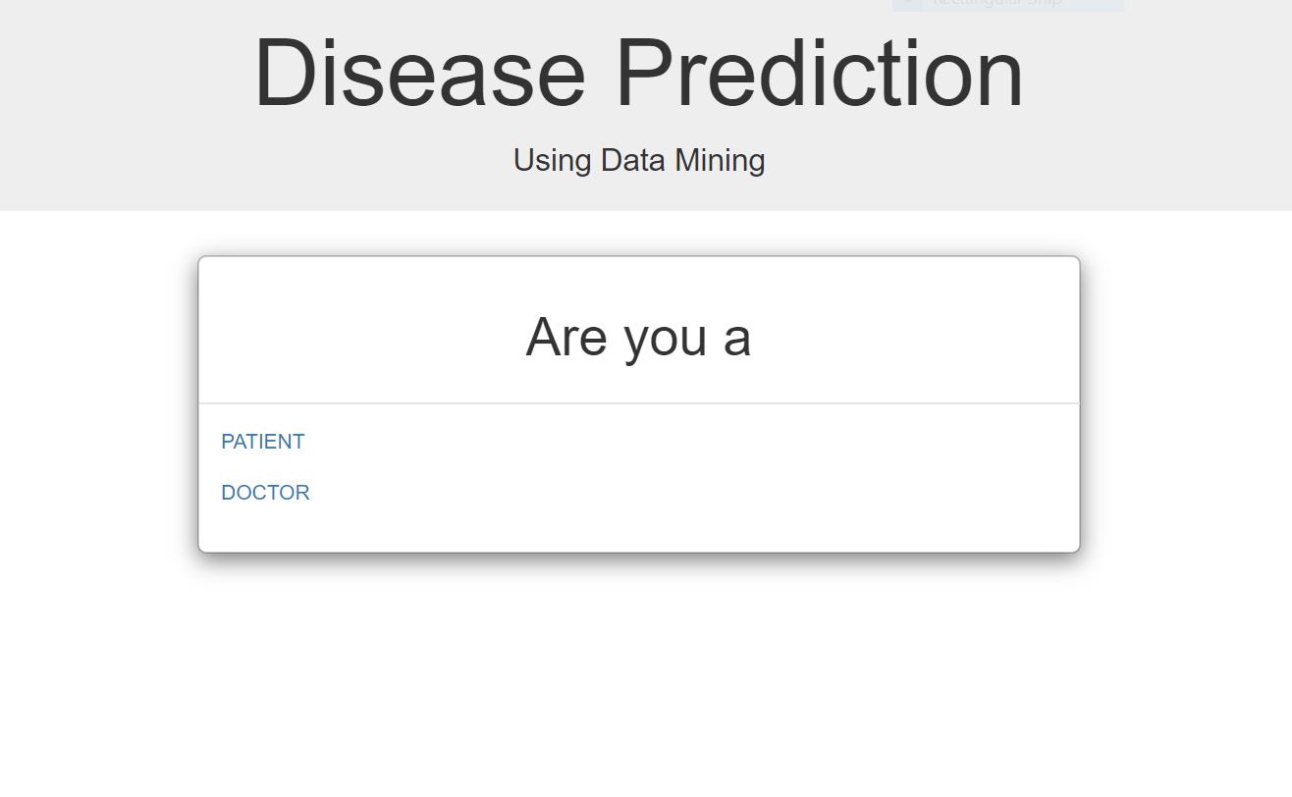

Registertation Page:

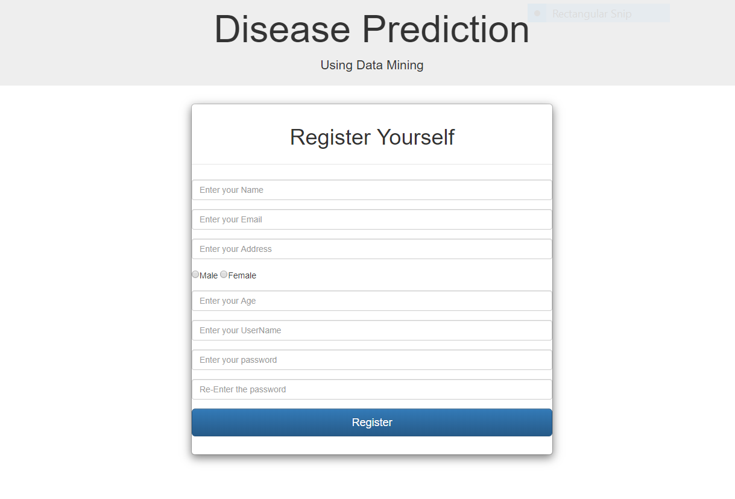

Collecting input data R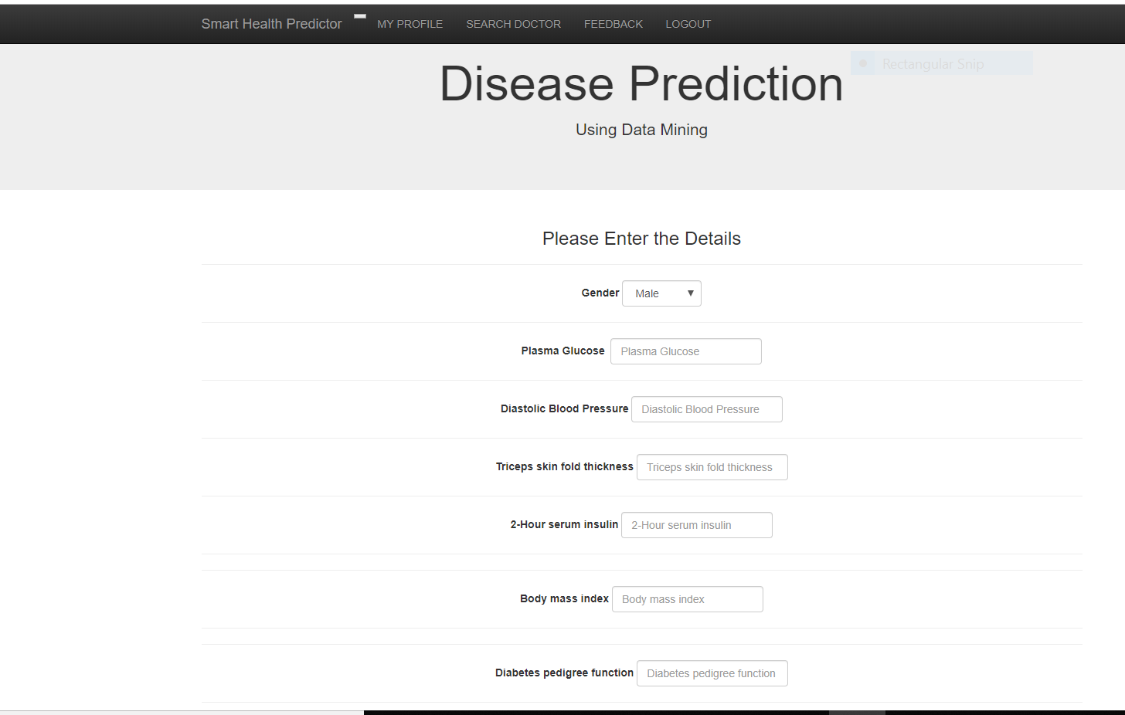

Report format:

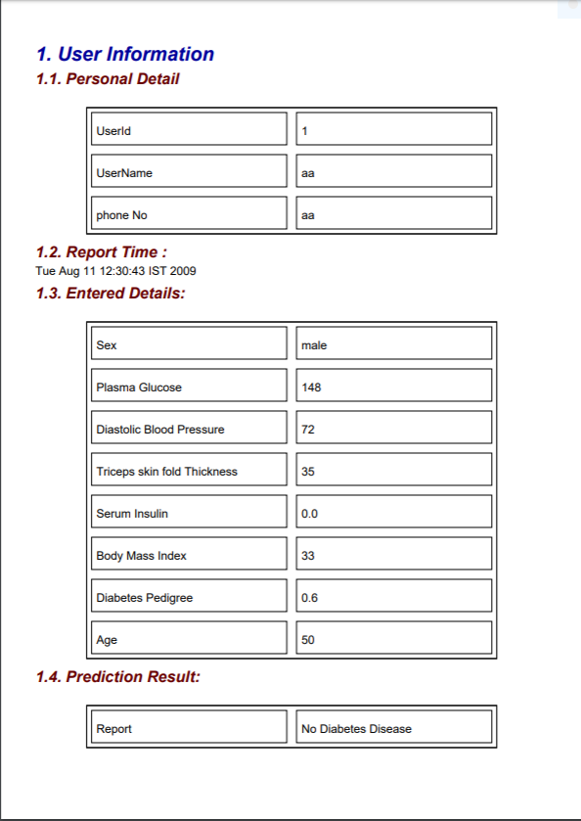

CHAPTER-6

SUMMARY AND CONCLUSION

6.1 Summary :

Medical data need to be processed to find out the pattern and extraction of data for analysis purposes, data mining and machine learning were used. In different sectors of medical, these techniques were found useful including medical image processing like brain tumour, cancer disease detection, diabetes, lever disease and heart disease, Parkinson disease identification, early detection of leukaemia etc. In this work, we considered diabetes, as it found to be a common and major disease amongst Indians. We considered Pima Indian diabetes database, evaluated in weka tool using Decision tree J48 algorithm. Our work achieved 91.2% efficiency. Applying convolution model of deep neural network is our interest of further study on this research. Also this research can be extended to apply feature selection method before training the model.
Using the web application we can predict whether a person is having diabetes or not. User need to enter the details through the web application.

6.2 Conclusions :

One of the important real-world medical problems is the detection of diabetes at its early stage. In this study, systematic efforts are made in designing a system which results in the prediction of disease like diabetes. During this work, decision tree j48 machine learning classification algorithm is studied and evaluated on various measures. Experiments are performed on Pima Indians Diabetes Database. Experimental results determine the adequacy of the designed system with an achieved accuracy of 73.30 % using the Decision tree classification algorithm. In future, the designed system with the used machine learning classification algorithms can be used to predict or diagnose other diseases. The work can be extended and improved for the automation of diabetes analysis including some other machine learning algorithms.

References

- Sajida Perveena, Muhammad Shahbaza, Aziz Guergachib, Karim Keshavjeec, "Performance Analysis of Data Mining Classification Techniques to Predict Diabetes" Procedia Computer Science 82 (2106) 115 – 121.
- Deepti Sisodia, Dilip Singh Sisodia, "Prediction of Diabetes using Classification Algorithms", International Conference on Computational Intelligence and Data Science (ICCIDS 2018)
- Santi Wulan Purnami, Abdullah Embong, Jasni Mohd Zain and S.P. Rahayu, " A New Smooth Support Vector Machine and Its Applications in Diabetes Disease Diagnosis", Journal of Computer Science 5 (12): 1003-1008, 2009
- Faezeh Ensan, Mohammad Hossien Yaghmaee, Ebrahim Bagheri, “FACT: A new Fuzzy Adaptive Clustering Technique”, The 11th IEEE Symposium on Computers and Communications, Sardinia, 26-29 June 2006
- Aishwarya, Gayathri, Jaisankar, “A Method for Classification Using Machine Learning Technique for Diabetes”, International Journal of Engineering and Technology 2013.
- Dhomse Kanchan B., M.K.M., 2016. Study of Machine Learning Algorithms for Special Disease Prediction using Principal of Component Analysis, in: 2016 International Conference on Global Trends in Signal Processing, Information Computing and Communication, IEEE.
- Esposito, F., Malerba, D., Semeraro, G., Kay, J., 1997. A comparative analysis of methods for pruning decision trees. IEEE Transactions on Pattern Analysis and MachineIntelligence19, 476–491.
- Fatima, M., Pasha, M., 2017. Survey of Machine Learning Algorithms for Disease Diagnostic. Journal of Intelligent Learning Systems and Applications.
- Kayaer, K., Tulay, 2003. Medical diagnosis on Pima Indian diabetes using general regression neural networks, in: Proceedings of the international conference on artificial neural networks and neural information processing.

Appendix
Source code

package com;
import java.awt.Toolkit;
import java.awt.event.KeyEvent;
import static java.lang.Math.pow;
import static java.lang.Math.sqrt;
import java.sql.*;
import java.util.logging.Level;
import java.util.logging.Logger;

/**
*
* @author vikram
*/
public class Diabetes {

public static double count(String table,String out) throws ClassNotFoundException{
double pc1=0;
Connection conn;
try {
Class.forName("com.mysql.jdbc.Driver");
conn = DriverManager.getConnection("jdbc:mysql://localhost:3306/healthprediction","root","password");
Statement s = conn.createStatement();
String query = null;
ResultSet rs = null;
int c1=0 ,c2=0 ,n=0;
query ="SELECT COUNT(*) AS Expr1 FROM "+table+" WHERE (class ='"+out+"')";
s.execute(query);
rs= s.getResultSet();
if(rs.next())

c1=Integer.parseInt(rs.getString(1));

query = "SELECT COUNT(*) AS Expr1 FROM "+table;
s.execute(query);
rs= s.getResultSet();
if(rs.next())

n = Integer.parseInt(rs.getString(1));
pc1 = (double)c1/n;
conn.close();
return pc1;
} catch (SQLException ex) {
Logger.getLogger(Diabetes.class.getName()).log(Level.SEVERE, null, ex);
}
return pc1;
}

public static double normal_distribution(double attr,double sd,double mean){
double ans=0;
double temp = pow(sqrt(2*3.142*sd),-1);
ans = temp*pow(2.71828,-pow(attr-mean,2)/2*pow(sd,2));
return ans;
}

private static double mean(String attr, String out, String table) throws ClassNotFoundException {
double ans=0,sum=0;
int n=0;
try {
Class.forName("com.mysql.jdbc.Driver");
Connection con11 = DriverManager.getConnection("jdbc:mysql://localhost:3306/healthprediction","root","password");
Statement s = con11.createStatement();
String query = null;
ResultSet rs = null;
query ="SELECT COUNT(*) AS Expr1 FROM "+table+" WHERE (class ='"+out+"')";
s.execute(query);
rs= s.getResultSet();
if(rs.next())
n=Integer.parseInt(rs.getString(1));

query ="SELECT SUM("+attr+") AS Expr1 FROM "+table+" WHERE (class ='"+out+"')";
s.execute(query);
rs= s.getResultSet();
if(rs.next())
sum=rs.getDouble(1);

ans = sum/n;
con11.close();

return ans;
} catch (SQLException ex) {
System.out.println("Exception in mean"+ex);
}
return ans;
}

private static double sd(String attr, double temp, String out, String table) throws ClassNotFoundException {
double ans=0,sum=0,base=0;
int n=0;
try {

Class.forName("com.mysql.jdbc.Driver");
Connection con22 = DriverManager.getConnection("jdbc:mysql://localhost:3306/healthprediction","root","password");
Statement s = con22.createStatement();
String query = null;
ResultSet rs = null;
query ="SELECT COUNT(*) AS Expr1 FROM "+table+" WHERE (class ='"+out+"')";
s.execute(query);
rs= s.getResultSet();
if(rs.next())
n=Integer.parseInt(rs.getString(1));

query ="SELECT "+attr+" AS Expr1 FROM "+table+" WHERE (class ='"+out+"')";
s.execute(query);
rs= s.getResultSet();
while(rs.next()){

sum=pow(rs.getDouble(1)-temp,2);

}
base=sum/(n-1);
ans=sqrt(base);
con22.close();

} catch (SQLException ex) {
System.out.println("Exception in sd"+ex);
}
return ans;
}

public static double pfind(double preg,double gluco,double bp,double skinthick,double insulin,double bmi,double pedigree,double age,String outcome,String table)
{
double ans = 0;
try{
double a,b,c,d,e,f,g,h,temp;

temp=mean("preg",outcome,table);
a=normal_distribution(preg,sd("preg",temp,outcome,table),temp);

if(a==0)
a=a+1;

temp=mean("gluco",outcome,table);
b=normal_distribution(gluco,sd("gluco",temp,outcome,table),temp);

if(b==0)
b=b+1;

temp=mean("bp",outcome,table);
c=normal_distribution(bp,sd("bp",temp,outcome,table),temp);

if(c==0)
c=c+1;

temp=mean("skinthick",outcome,table);
d=normal_distribution(skinthick,sd("skinthick",temp,outcome,table),temp);

if(d==0)
d=d+1;

temp=mean("insulin",outcome,table);
e=normal_distribution(insulin,sd("insulin",temp,outcome,table),temp);

if(e==0)
e=e+1;

temp=mean("bmi",outcome,table);
f=normal_distribution(bmi,sd("bmi",temp,outcome,table),temp);

if(f==0)
f=f+1;

temp=mean("pedigree",outcome,table);
g=normal_distribution(pedigree,sd("pedigree",temp,outcome,table),temp);

if(g==0)
g=g+1;

temp=mean("age",outcome,table);
h=normal_distribution(age,sd("age",temp,outcome,table),temp);

if(h==0)
h=h+1;

ans=a*b*c*d*e*f*g*h;

System.out.println("Answer----->"+ans);
}
catch(Exception e)
{
System.out.println("Exception:"+ e);
System.out.println("Exception in pfind");
}
return ans;
}

// private void check(java.awt.event.KeyEvent evt){
// char c = evt.getKeyChar();
// if(!(Character.isDigit(c) || c == KeyEvent.VK_BACK_SPACE || c == KeyEvent.VK_DELETE || c == KeyEvent.VK_PERIOD)){
// getToolkit().beep();
// evt.consume();
// }
// }

}

/*
* To change this license header, choose License Headers in Project Properties.
* To change this template file, choose Tools | Templates
* and open the template in the editor.
*/
package com;

import java.io.File;
import java.io.IOException;
import java.io.PrintWriter;
import java.nio.file.Files;
import javax.servlet.ServletException;
import javax.servlet.http.HttpServlet;
import javax.servlet.http.HttpServletRequest;
import javax.servlet.http.HttpServletResponse;

/**
*
* @author vikra
*/
public class pdfservlet extends HttpServlet {

/**
* Processes requests for both HTTP <code>GET</code> and <code>POST</code>
* methods.
*
* @param request servlet request
* @param response servlet response
* @throws ServletException if a servlet-specific error occurs
* @throws IOException if an I/O error occurs
*/
protected void processRequest(HttpServletRequest request, HttpServletResponse response)
throws ServletException, IOException {
response.setContentType("text/html;charset=UTF-8");
try (PrintWriter out = response.getWriter()) {
/* TODO output your page here. You may use following sample code. */
out.println("<!DOCTYPE html>");
out.println("<html>");
out.println("<head>");
out.println("<title>Servlet pdfservlet</title>");
out.println("</head>");
out.println("<body>");
out.println("<h1>Servlet pdfservlet at " + request.getContextPath() + "</h1>");
out.println("</body>");
out.println("</html>");
}
}

// <editor-fold defaultstate="collapsed" desc="HttpServlet methods. Click on the + sign on the left to edit the code.">
/**
* Handles the HTTP <code>GET</code> method.
*
* @param request servlet request
* @param response servlet response
* @throws ServletException if a servlet-specific error occurs
* @throws IOException if an I/O error occurs
*/
@Override
protected void doGet(HttpServletRequest request, HttpServletResponse response)
throws ServletException, IOException {
processRequest(request, response);
}

/**
* Handles the HTTP <code>POST</code> method.
*
* @param request servlet request
* @param response servlet response
* @throws ServletException if a servlet-specific error occurs
* @throws IOException if an I/O error occurs
*/
@Override
protected void doPost(HttpServletRequest request, HttpServletResponse response)
throws ServletException, IOException {
// processRequest(request, response);
File file = new File("C:\\Reports\\report.pdf");
response.setHeader("Content-Type", getServletContext().getMimeType(file.getName()));
response.setHeader("Content-Length", String.valueOf(file.length()));
response.setHeader("Content-Disposition", "inline; filename=\"report.pdf\"");
Files.copy(file.toPath(), response.getOutputStream());
}

/**
* Returns a short description of the servlet.
*
* @return a String containing servlet description
*/
@Override
public String getServletInfo() {
return "Short description";
}// </editor-fold>

}

package com;

import Service.Service;
import bean.Appointment;
import bean.PatientBean;
import java.io.IOException;
import java.io.PrintWriter;
import javax.servlet.ServletException;
import javax.servlet.http.HttpServlet;
import javax.servlet.http.HttpServletRequest;
import javax.servlet.http.HttpServletResponse;
import javax.servlet.http.HttpSession;

public class bookAppointment extends HttpServlet {

protected void processRequest(HttpServletRequest request, HttpServletResponse response)
throws ServletException, IOException {

String n =request.getParameter("name");
String e =request.getParameter("email");
String g =request.getParameter("gender");
String d =request.getParameter("adate");
String t =request.getParameter("atime");
System.out.println("name" + n);

Service obj=new Service();

HttpSession session = request.getSession();

String DocEmail = (String) session.getAttribute("dEmail");
System.out.println("Doc name"+DocEmail);
String PatUsername = (String) session.getAttribute("userName");
PatientBean obj1 =new PatientBean();

obj1 = obj.getPatientAge(PatUsername);

Appointment obj2 =new Appointment();

obj2.setAge(obj1.getAge());
obj2.setDate(d);
obj2.setTime(t);
obj2.setGender(g);
obj2.setName(n);
obj2.setEmail(e);
obj2.setDocUserName(DocEmail);

int i = obj.insertAppointmentDetails(obj2);
response.sendRedirect("PatientHomePage1.jsp");

// if(i>0)
// {
// response.sendRedirect("PatientHomePage1.jsp");
// }
// else
// {
// System.out.println("Error");
// }

}

// <editor-fold defaultstate="collapsed" desc="HttpServlet methods. Click on the + sign on the left to edit the code.">
/**
* Handles the HTTP <code>GET</code> method.
*
* @param request servlet request
* @param response servlet response
* @throws ServletException if a servlet-specific error occurs
* @throws IOException if an I/O error occurs
*/
@Override
protected void doGet(HttpServletRequest request, HttpServletResponse response)
throws ServletException, IOException {
processRequest(request, response);
}

/**
* Handles the HTTP <code>POST</code> method.
*
* @param request servlet request
* @param response servlet response
* @throws ServletException if a servlet-specific error occurs
* @throws IOException if an I/O error occurs
*/
@Override
protected void doPost(HttpServletRequest request, HttpServletResponse response)
throws ServletException, IOException {
processRequest(request, response);
}

/**
* Returns a short description of the servlet.
*
* @return a String containing servlet description
*/
@Override
public String getServletInfo() {
return "Short description";
}// </editor-fold>

}

